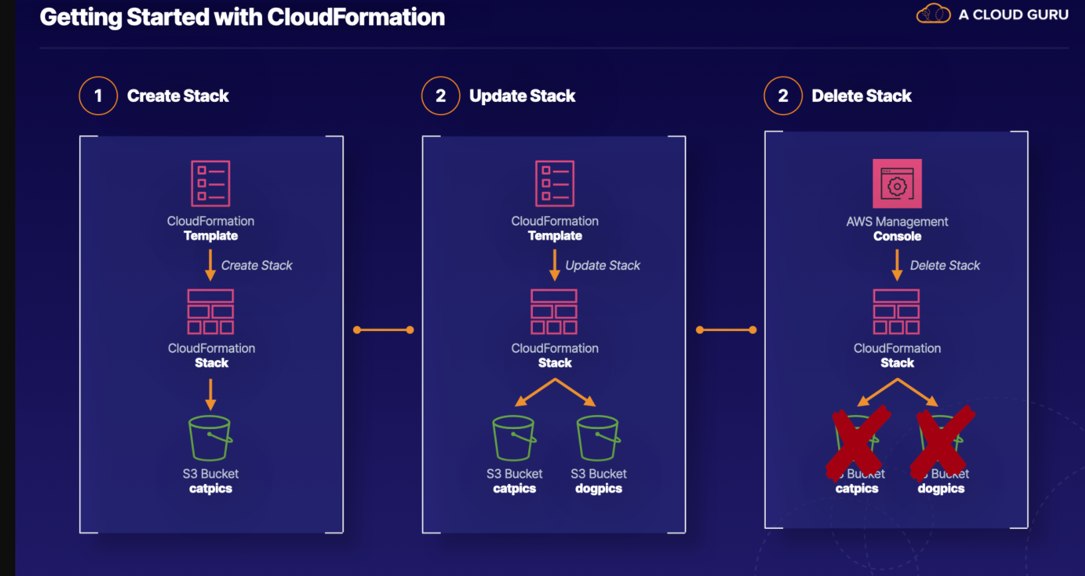

**Getting Started with CloudFormation**

**Introduction**

CloudFormation is a powerful automation service within AWS. It can be used to create simple or complex sets of infrastructure any number of times. This hands-on lab provides a gentle introduction to CloudFormation, using it to create and update a number of S3 buckets. By the end of this hands-on lab, you will be comfortable using CloudFormation and can begin experimenting with your own templates.

**Solution**

Log in to the live AWS environment using the credentials provided, and make sure you are in the us-east-1 (N. Virginia) region.

The CloudFormation templates and other hands-on lab files can be found on [GitHub](https://github.com/ACloudGuru-Resources/Course-Certified-Solutions-Architect-Associate/tree/master/labs/getting_started_with_cfn). Navigate to the needed file and choose the RAW view. From there, use the **Save As...** functionality in your browser.

A list of AWS resources and what happens when updates occur can be found [online](https://docs.aws.amazon.com/AWSCloudFormation/latest/UserGuide/aws-template-resource-type-ref.html).

**Create a CloudFormation Stack**

1. Download the **[createstack.json](https://raw.githubusercontent.com/ACloudGuru-Resources/Course-Certified-Solutions-Architect-Associate/master/labs/getting_started_with_cfn/createstack.json" \t "_blank)**[file](https://raw.githubusercontent.com/ACloudGuru-Resources/Course-Certified-Solutions-Architect-Associate/master/labs/getting_started_with_cfn/createstack.json" \t "_blank) by right-clicking and selecting **Save As** functionality.
2. In the AWS console, navigate to CloudFormation.
3. Click **Create stack** > **With new resources (standard)**.
4. Select **Template is ready**.
5. Select **Upload a template file**.
6. Click **Choose file**.
7. Browse to the createstack.json file you downloaded and saved.
8. Select and upload it, and click **Next**.
9. Name the stack "cfnlab".
10. Click **Next**.
11. Scroll through the available stack options, leaving them all at the defaults, and click **Next**.
12. Review your selections and click **Create stack**.
13. Refresh the page to watch the progress.
14. Navigate to S3. We didn't specify a name in the json file for this bucket, so AWS names it with the **<STACK\_NAME>-<LOGICAL\_VOLUME\_NAME>-<RANDOM\_STRING>** format. Yours will be: *cfnlab-catpics-<RANDOM\_STRING>*.

**Update the CloudFormation Stack**

**Compare the Original and Updated Templates**

1. Download and save the [**updatestack1.json**](https://raw.githubusercontent.com/ACloudGuru-Resources/Course-Certified-Solutions-Architect-Associate/master/labs/getting_started_with_cfn/updatestack1.json) and [**updatestack2.json**](https://raw.githubusercontent.com/ACloudGuru-Resources/Course-Certified-Solutions-Architect-Associate/master/labs/getting_started_with_cfn/updatestack2.json) files like you did for createstack.json.
2. Open the createstack.json, updatestack1.json, and updatestack2.json files in a text editor.
3. Compare the contents of the createstack.json and updatestack1.json files, focusing on the differences in the Resources section. You should see that the updatestack1.json file contains an additional logical resource named "dogpics".
4. Compare the contents of the createstack.json and updatestack2.json files, once again focusing on the differences in the Resources section. You should see that the updatestack2.json file contains an additional logical resource named "dogpics" and includes a bucket name of "catsareawesome123" for the "catpics" resource.

**Update #1**

1. Navigate to CloudFormation.
2. Select the cfnlab stack, and click **Update**.
3. Select **Replace current template**.
4. Select **Upload a template file**.
5. Click **Choose file**, and select and upload updatestack1.json.
6. Click **Next** > **Next** > **Next**.
7. In the **Change set preview** section, review the changes that will be made based on the updatestack1.json template. You should be adding the "dogpics" resource.
8. Click **Update stack**.
9. Refresh the page to watch the progress.
10. Once it's finished updating, navigate to S3. You should see the new dogpics bucket.

**Remove the Update**

1. Navigate back to CloudFormation.
2. Select the cfnlab stack, and click **Update**.
3. Select **Replace current template**.
4. Select **Upload a template file**.
5. Click **Choose file**, and select and upload createstack.json again.
6. Click **Next** > **Next** > **Next**.
7. In the **Change set preview** section, review the changes that will be made based on the createstack.json template. You should be removing the "dogpics" resource.
8. Click **Update stack**.
9. Refresh the page to watch the progress.
10. Once it's finished updating, navigate to S3. You should see the dogpics bucket is now gone.

**Update #2**

1. Navigate to the updatestack2.json file that is open in the text editor.
2. Change the 123 characters in catsareawesome123 to something unique (e.g., your birthday and today's date).
3. Save the file.
4. In the CloudFormation console, select the cfnlab stack, and click **Update**.
5. Select **Replace current template**.
6. Select **Upload a template file**.
7. Click **Choose file**, and select and upload updatestack2.json.
8. Click **Next** > **Next** > **Next**.
9. In the **Change set preview** section, review the changes that will be made based on the updatestack2.json template. You should be modifying the "catpics" resource and adding the "dogpics" resource.
10. Click **Update stack**.
11. Refresh the page to watch the progress.
12. Once it's finished updating, navigate to S3. You should see 2 changes: The dogpics bucket is back, and the catpics bucket has been replaced with the catsareawesome bucket.

**Add CloudFormation Stacks**

**Create a Stack with updatestack2.json**

1. Navigate to CloudFormation.
2. Click **Create stack** > **With new resources (standard)**.
3. Select **Template is ready**.
4. Choose to **Upload a template file** and **Choose file**.
5. Select and upload updatestack2.json.
6. Click **Next**.
7. Name the stack "cfnlab2".
8. Click **Next** > **Next**.
9. Accept the remaining defaults, and click **Create stack**.
10. Refresh the page to watch the progress.
11. Note it eventually fails, because you can't have another S3 bucket with the same name (in this case, a bucket with the catsareawesome name already exists).

**Create a Stack with updatestack1.json**

1. Click **Create stack** > **With new resources (standard)**.
2. Select **Template is ready**.
3. Choose to **Upload a template file** and **Choose file**.
4. Select and upload updatestack1.json.
5. Click **Next**.
6. Name the stack "cfnlab3".
7. Click **Next** > **Next**.
8. Accept the remaining defaults, and click **Create stack**.
9. Refresh the page to watch the progress.
10. Once it's complete, navigate to S3, where you should see 2 new buckets: cfnlab3-catpics-<RANDOM\_STRING> and cfnlab3-dogpics-<RANDOM\_STRING>.

**Delete CloudFormation Stacks**

1. Navigate to CloudFormation.
2. Select cfnlab3.
3. Click **Delete**.
4. In the dialog box, click **Delete stack**.
5. Click the cfnlab3, and then click the **Events** tab to see the resources being deleted.
6. Click **Stacks** in the breadcrumb link trail at the top.
7. Select cfnlab2.
8. Click **Delete**.
9. In the dialog box, click **Delete stack**.
10. Click the cfnlab2, and then click the **Events** tab to see the resources being deleted.
11. Click **Stacks** in the breadcrumb link trail at the top.
12. Select cfnlab.
13. Click **Delete**.
14. In the dialog box, click **Delete stack**.
15. Click the cfnlab, and then click the **Events** tab to see the resources being deleted.
16. Once it's all done, navigate to S3. You should see all the cfnlab buckets are gone, as well as the catsareawesome bucket.

**Conclusion**

We've managed to use templates to create stacks and related resources, and we were able to get things cleaned up when we were done with them in pretty short order. Congratulations!